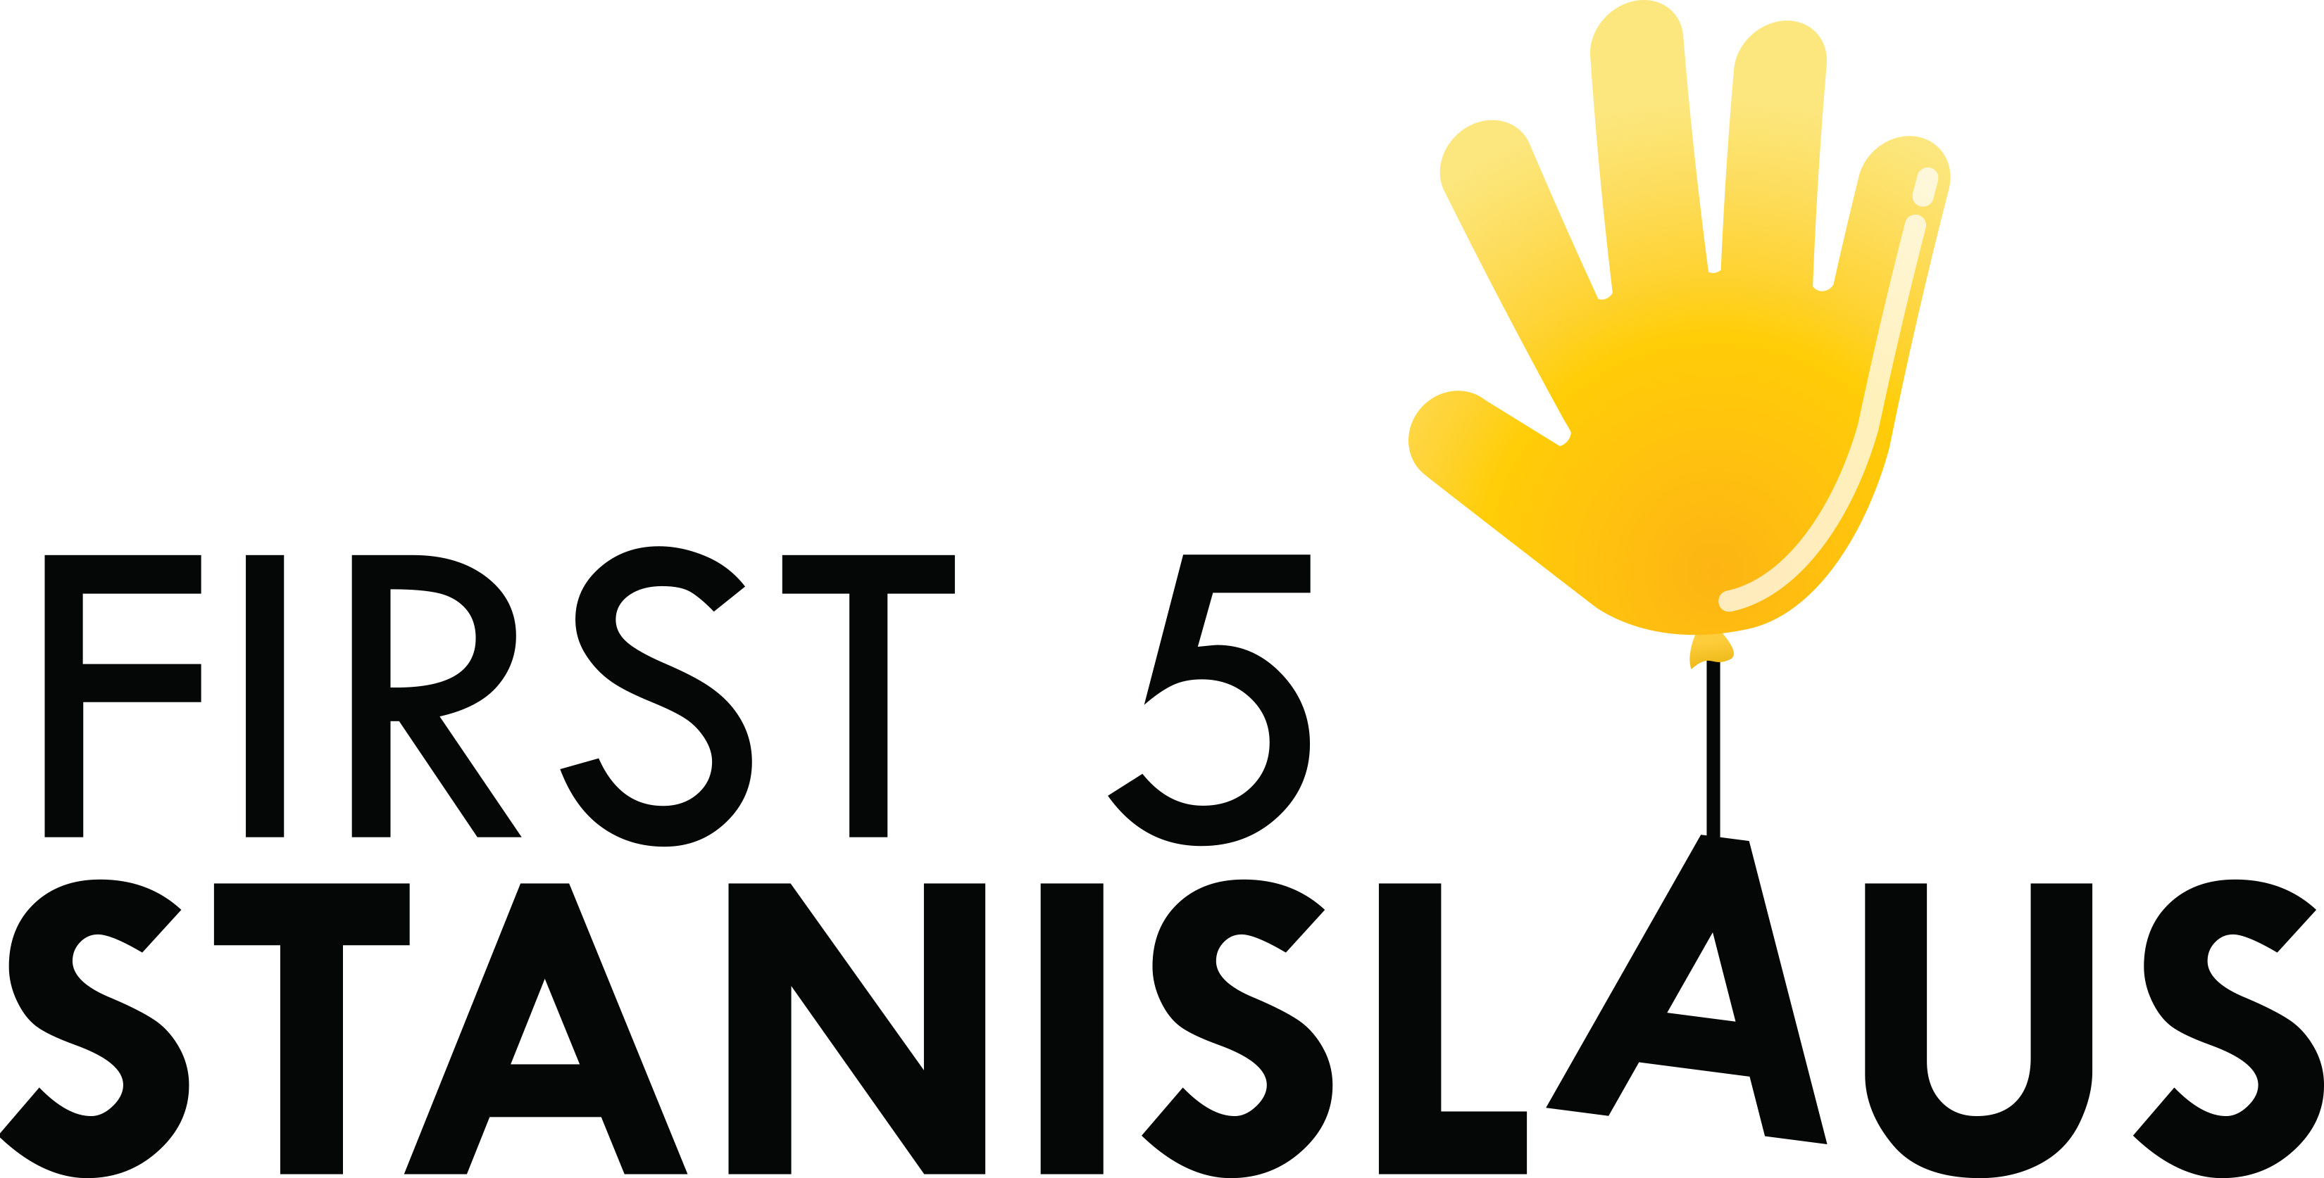
Program Budget Revision Request
Part 1. Budget Narrative

Grantee (Partner) Name:
Contract Program Name:
Prepared by:
Phone Number:
E-mail:
Date:
Complete the Part 1 and Part 2 Budget Revision Forms when you need to modify your approved budget. A Budget Revision should not increase or decrease the total approved contract. Submit the completed Part 1 and Part 2 Budget Revision Forms via email to the Stanislaus Children and Families Commission Fiscal Representative.

Part I. Description of Change
(Please tell us what you want to change in a manner that is simple to understand. Also, please use an appropriate level of detail to help us understand the change. Any change request should also be included on the Part 2. Budget Worksheet)

Part II. Justification of Change
(Please tell us WHY the budget revision is necessary)

Part III. Agreement Compliance
(Please tell us how the requested change(s) impacts the program and supports or enhances the Scope of Work or Scorecard. Include any changes in services that may result.)

